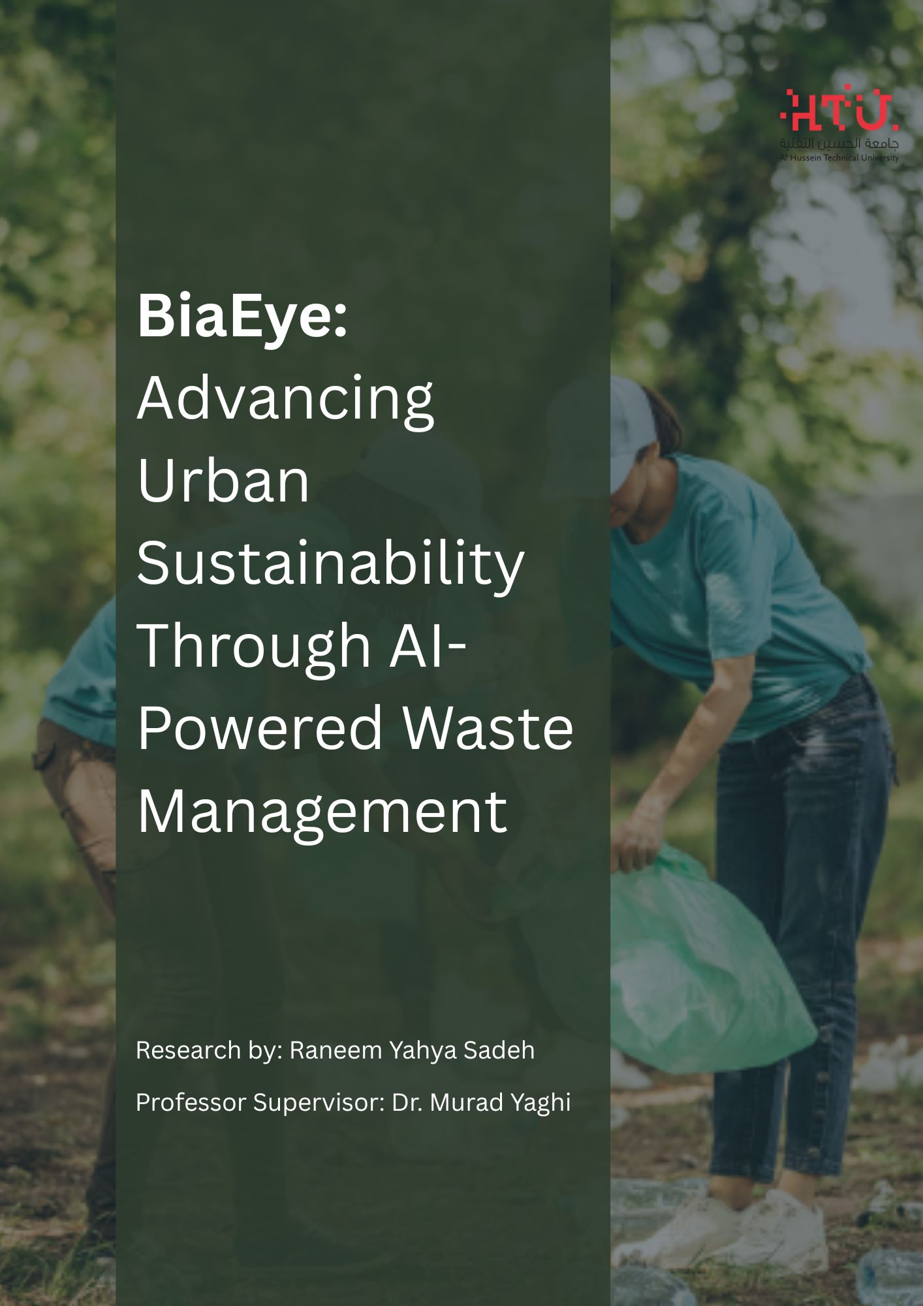

Table of Contents

Abstract 3

1. Introduction 3

1.1 Urban Waste Management Challenges 3

1.2 Impact of Illegal Dumping 4

1.3 Computer Vision 5

1.4 Convolutional Neural Network 5

1.5 BiaEye: A Novel Solution 7

2. Background and Literature Review 8

2.1 Evolution of Waste Management Technologies 8

2.2 Comparative Analysis of Existing Solutions 9

2.3 Gap Analysis 12

3. Methodology 12

3.1 Data 12

3.2 Real-Time Detection System 16

4. Computer Vision Models: Techniques and Comparisons 19

4.1 Models Used in BiaEye 19

4.2 Model Comparison 21

4.3 Analysis of Model Performance 23

4.4 Model Selection for BiaEye 24

4.5 Geospatial Analytics 25

5. Achievements 26

6. Ethical and Privacy Considerations 26

7. Challenges and Future Work 26

8. Conclusion 27

# Abstract

Can you imagine that in 2050 the amount of waste in the world will increase by more than 70%? This is not a normal number, as there are many areas in Amman that suffer from poor environment, health, social and even economic problems due to empty plots of land that are converted by residents over time into landfills. *So, how can artificial intelligence and community engagement be combined to effectively detect and reduce illegal waste dumping in urban areas like Amman, Jordan?* Here I came up with the project “BiaEye”, which is an integrated artificial intelligence system that works on waste detection and sends a report to the responsible authority to make the appropriate decision based on this data. I developed a computer vision model and did a complete annotation of a large number of images that I obtained from Kaggle. Actual images were taken from Amman to be the Accurate model in Jordan. The data annotation process was explained in detail, as well as the code and analysis that I did to find out which model is the best. The models I used are YOLOv8, YOLOv11 and YOLOv5. I found the best model for waste detection is the YOLOv11 model. BiaEye participated in many competitions and was chosen for incubation by the Ministry of Digital Economy and Entrepreneurship in Jordan. In line with the recommendation of the Minister of Digital Economy and Entrepreneurship and the Minister of Youth at the Youth Conference 2024. BiaEye also had the opportunity to travel to Azerbaijan and present the project at COP29. I also built a website for the public to explore the project and benefit from the features we offer, such as being rewarded for contributing to waste removal or sharing the website to reach a wider audience. Together, we can create a better environment for our generation and future generations.

# 1. Introduction

## 1.1 Urban Waste Management Challenges

Urban waste management has emerged as one of modern cities most pressing challenges. And as well the new studies indicate that our municipal solid waste generation was expected that sadly have been reachen as 3.4 billion as tonnes by the year 2050, which shows that reperesents a 70% increase from current levels (World Bank, 2022). This challenge is going to affects various aspects of life, including the health and the environment and the economy and the society. For example, according to studies conducted by the Ministry, a piece of land in the Al-Nuzha area of Amman, caused by the negligence of both residents and waste management authorities, accumulated 50 tons of waste in 2023. This led to a disaster that caused 300% increase in the rat population, resulting in the spread of respiratory and digestive diseases, especially among the children, as this landfill was located near a neighborhood school. The economic and social impact was equally severe where the land prices in the area decreased significantly, and the unsightly view deterred visitors. The removal of this landfill cost 15,000 Jordanian dinars.

The proliferation of illegal dumping in urban areas has become a big problem, which is leading to cascading environmental, and health, and economic consequences. Improper waste disposal not only disrupts ecosystems but also it significantly impacts urban residents' quality of life. The breeding grounds for disease vectors is been created from the accumulation of uncollected waste and from these creations the mosquitoes and rats, contributing to public health crises and as you know poor waste management leads to clogged sewer systems which in turn leads to urban flooding during heavy rainfall and causes costly damage to infrastructure. Rapid urbanization and population growth have significantly increased waste production placing unprecedented pressure on existing waste management systems. Municipalities around the world lack the necessary resources for monitoring and enforcement while expanding urban areas lack sufficient waste collection infrastructure to meet the growing demand and for example in developing countries the lack of waste sorting at source complicates recycling efforts reducing the overall efficiency of waste management systems. Meanwhile reliance on outdated landfill methods results in harmful greenhouse gas emissions such as methane which will contribute to future climate change. These challenges are exacerbated by socioeconomic factors. Public awareness and community participation in waste management are low with residents failing to understand the importance of proper disposal practices. This lack of participation leads to broader efforts to establish sustainable waste management systems. The financial burden on municipalities for waste management is enormous. Insufficient budget allocations lead to poor waste collection rates and insufficient investment in modern waste treatment technologies. For example in many cities informal waste collectors play a role in managing recyclables but they remain unrecognized and unsupported a major inequality in current systems.

Technological limitations are also significant in exacerbating these challenges. The absence of smart monitoring systems to track waste generation patterns makes it difficult for municipalities to allocate resources efficiently. Traditional manual methods for waste monitoring are labor-intensive and inaccurate. Innovative technologies such as artificial intelligence IoT-enabled waste trucks and geospatial analytics have the potential to transform waste management practices by providing actionable insights.

## 1.2 Impact of Illegal Dumping

Illegal waste dumping poses significant threats to sustainability and health, with far-reaching consequences for both environmental quality and municipal resources. Research by Zhang et al. (2022) showed that unauthorized waste disposal sites increase soil pollution by up to 45% and local water pollution levels by 30%. These environmental impacts are particularly concerning in urban areas, where population density amplifies the potential health risks associated with soil and water contamination and uncontrolled waste accumulation disrupts ecosystems, introduces hazardous chemicals into the food chain, and threatens biodiversity. Degradation reduces the capacity of urban ecosystems to provide services such as air and water purification, increasing the environmental costs of illegal waste dumping.

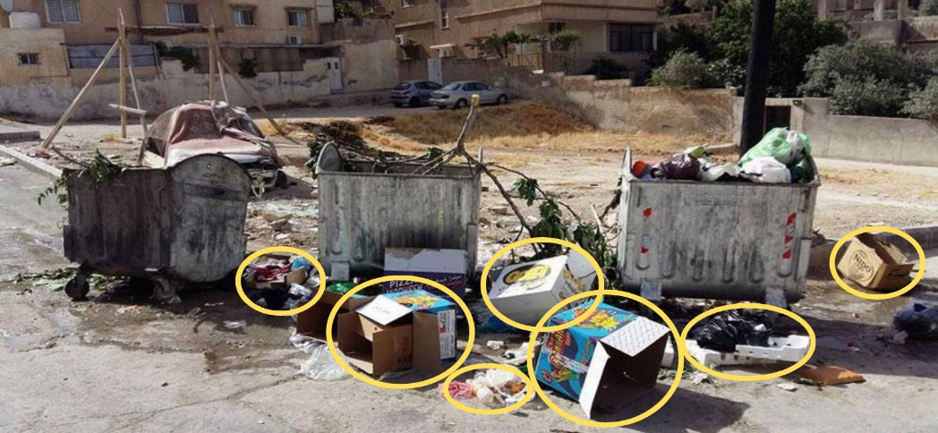

The economic impacts are equally dire, with municipalities worldwide spending an estimated $8–10 billion annually on landfill cleanup. Sometimes, restoring severely damaged sites requires additional investments in equipment and labor. Illegal dumping also reduces the aesthetic and functional value of urban spaces, decreasing property values, declining tourism, and negatively impacting local businesses and as for society, illegal dumping disproportionately affects poor communities, where inadequate infrastructure and limited resources expose residents to health risks. The widespread dumping of waste in these areas distorts the appearance of neighborhoods, perpetuating cycles of poverty and social exclusion. Children are at risk of disease and polluted environments, underscoring the need for waste management solutions.

## 1.3 Computer Vision

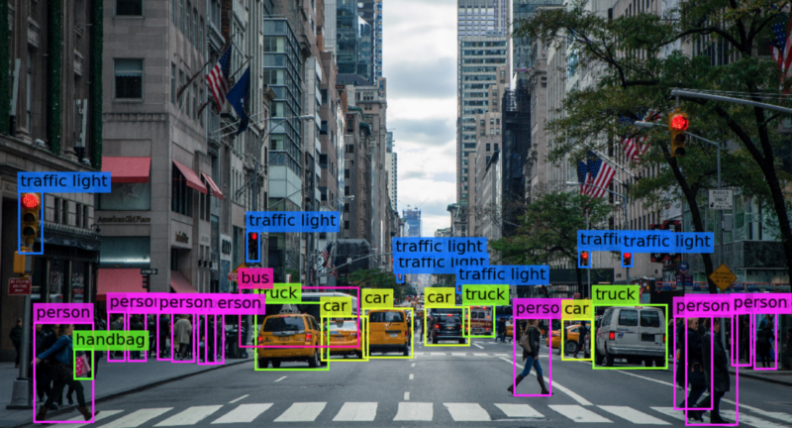

To be able to detect the largest possible amount of trash on sidewalks, the ground, and around trash cans from millions of images and make all this happen quickly, we will need a technology that helps us process the large amount of data, images, or videos, and trains on them to produce the best results. This technology is computer vision, a broad and highly developed technology that has helped in the development of numerous projects and applications so one of its key areas that I'm going to use is the trash or illegal dumping detection which plays a crucial role in sectors like environmental sustainability and waste management and smart city initiatives. Over time, the integration of deep learning into computer vision has revolutionized trash detection which does make it more accurate and efficient.

## 1.4 Convolutional Neural Network

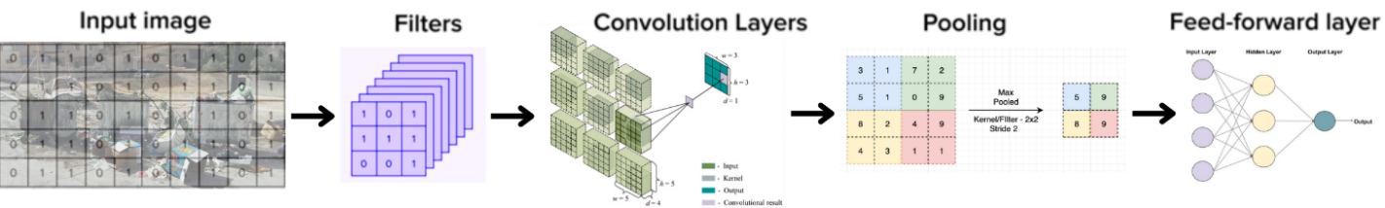

At the core of modern computer vision systems is the Convolutional Neural Network which is a powerful deep learning model that was inspired by the human visual system. CNNs shine at identifying patterns and features in images through multiple layers of processing them. Unlike traditional methods that depend on manual feature extraction, CNN automatically learn primary and important characteristics from data which make it more useful for specific and scalable waste detection solutions and now lets talk about the evolution of CNN that have started from a research of a deep learning that gained momentum in 2006 when Geoffrey Hinton and his team introduced their groundbreaking ideas, he and his team demonstrated that deep neural networks with multiple layers could effectively learn complex features and they proposed a layer by layer initialization approach to improve training. This advancement led to a increase of interest in deep learning, influencing not only computer vision but also speech recognition and language processing for the image classification and object detection tasks the process is going to begins with an input image, which is a matrix of pixel values representing visual information.

But before talking about CNN model, lets talk about annotating the images of the dataset that we are going to use, it is about labeling the images with text to highlight key details the model needs to learn, videos can also be annotated continuously as a stream or frame by frame all this is going to help the model identify important features these labeled images train the model through supervised learning and once it is trained the model should recognize similar features in new, unlabeled images and those images can be 2D or 3D not only images but also videos in 2D and 3D.

|  |  |
| --- | --- |
|  |  |

There are three main types of image annotation, image classification and object detection and segmentation, for the classification it does identify and categorize similar objects represented within our image dataset and this is going to enable the ML to know the objects within unlabeled images by leveraging its training on labeled images of similar objects and this all is called tagging like lets take and example of animals with labels such as ‘dog’ and ‘cat’, and now lets talk about object detection the technique that I’m going to use in my project where its about putting labels in an images with a class, like as in my project in a image where there is a lot of trash on the street and there is plants cars and other objects I’m going to label only the trash in boxes with its class ‘Trash’, but also I can label more than one object in one image such as ‘Trash’ and ‘Plants’ and so on I could annotate each of them separately in the same image, but lets agree that segmentation is the most accurate it does have two types first is the semantic segmentation where objects are labeled under the same identification this is used when you want to know if something is there and where it is and sometimes, its size and shape, and other type is more accurate is the instance segmentation where it does track and counts the existence and the location and the size and the shape of the object in the image.

Going back to the CNN model, after we identify the pixels of the image this image is going to be divided into smaller grid like sections to facilitate processing, after this we are going to use the filters or as its known at coding kernels where they are going to be applied on the image and they are small where these learnable weight matrices are going to slide over the input image which will enable it to detect features like edges and textures and patterns, and from the filtered output the convolution layer can extract hierarchical spatial features, as well the kernels are able to detect different characteristics lets say that in the first layers it could detect the horizontal and vertical edges and the deeper layers it will detect more complex patterns and after the convolution process that have been made after filtering its output gets a pooling operation, and its typically max pooling which is going to reduce the dimensionality by selecting the highest value in a small region, preserving essential information while reducing computational complexity this operation is going to enhance the translational invariance and making sure that small shifts in the input image do not significantly affect predictions and the results of the lower-dimensional feature maps are then flattened into a vector and passed through a feed-forward neural network this is going to look as linear that will make it the best to enter the model and which consists of fully connected layers so these layers process the extracted features and learn patterns to make predictions and at least we get to the final layer where it does uses a activation function such as the famous one SoftMax and the Sigmoid and its for generating output probabilities. The CNN is going to optimizes its parameters through backpropagation and gradient descent and also through setting the filters weights to minimize classification error over the time this is going to allow it to excel in tasks such as image recognition and the object detection and the segmentation by learning automatically the spatial hierarchies of the features from raw image data.

## 1.5 BiaEye: A Novel Solution

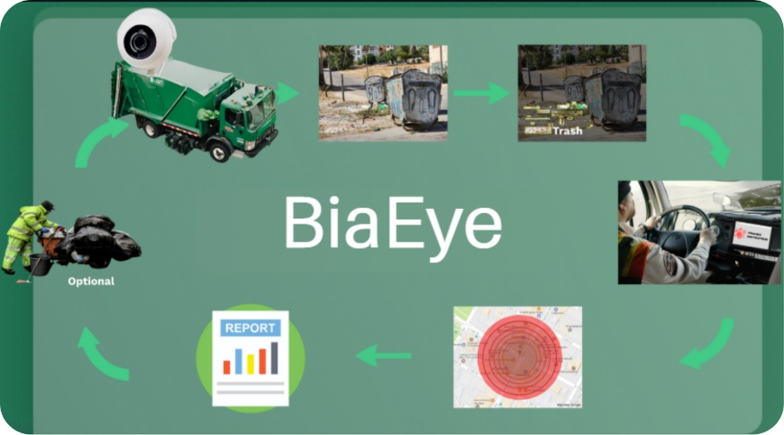

BiaEye achieve the Decent Work and Economic Growth, which is the goal number '8', by creating opportunities for economic growth through our optimization of waste management processes that the system makes. BiaEyes reward and banishment mechanisms for community participation promote inclusive economic development and it works by giving rewards for individuals and businesses for being responsible to the waste disposal practices. And by reducing the financial burden associated with illegal dumping, municipalities can reallocate resources toward job creation and sustainable infrastructure development.

Aligned with the goal number '9' from SDG which is Industry, Innovation, and Infrastructure, BiaEye uses a cutting-edge technologies such as AI tools and geospatial analytics to develop waste management infrastructure. The implementing of the advanced AI technologies, which are the computer vision models, like YOLO v8, this shows the role of innovation in addressing urban challenges. And as well as the system supports the development of smart cities by integrating data-driven insights into municipal decision-making processes.

And as well the systems core alignment with the 11th SDG which is the Sustainable Cities and Communities where it lies in its mission to create cleaner and healthier urban spaces and this is going to happen by addressing the root causes of illegal dumping BiaEye enhances urban livability and promotes sustainable behavioral changes in the communities. Its integration with municipal operations make sure about the long term improvements in waste management efficiency and environmental sustainability.

and at least it does also plays a critical role in SDG 13 which is the Climate Action and this is by reducing the environmental impact of improper waste disposal. we all know the methane emissions from unmanaged landfills are really significant contributor to climate change and by minimizing illegal dumping and optimizing waste collection, BiaEye is going to help to combat climate change and this by lowering the gas emissions from the greenhouse and also is going to support the global efforts.

The unique approach of these systems goes beyond technological innovation and integrating community engagement through carefully designed incentive mechanisms. For example so residents are encouraged to report incidents of illegal waste dumping via an easy-to-use mobile app and earning reward points that can be redeemed for municipal services or discounts on utility bills. These incentives foster a sense of collective responsibility and encourage proactive behavior among community members and the integration of geospatial analytics allows municipalities to identify high-risk areas and as well this enabling targeted interventions and more efficient resource allocation and also this system also leverages the latest computer vision models as such as YOLO v8 and this is for real-time waste detection and classification. This technological capability significantly reduces reliance on manual inspections and freeing up valuable human resources for other vital tasks. By combining advanced AI-based systems with community engagement strategies as well BiaEye system bridges the gap between innovation and inclusivity and creating a comprehensive framework for addressing urban waste management challenges. BiaEye's broader impact extends across environmental and economic and social dimensions. By reducing illegal waste dumping and the system contributes to cleaner urban environments and does improve public health and enhanced biodiversity. Economically it does improved waste management processes reduce municipal operating costs while increasing resource efficiency. Socially the project strengthens community bonds and encourages a shared commitment to sustainability. BiaEye embodies the potential of leveraging technology and collective action to address one of the most pressing issues facing modern cities, paving the way for a cleaner and more sustainable urban future and as well it does addresses these challenges through an innovative combination of artificial intelligence and community engagement, representing a significant advance in urban waste management technology. The system's objectives are closely aligned with UN Sustainable Development Goals 11 and 12, which specifically focus on sustainable cities and responsible consumption. By instantly detecting and monitoring illegal waste dumping activities, BiaEye enables municipalities to respond promptly to waste management issues while improving resource allocation through data-driven decision-making.

# 2. Background and Literature Review

## 2.1 Evolution of Waste Management Technologies

In recent years, significant advancements have been made in waste management technologies. Kumar et al. (2021) categorises these developments into three generations:

1. Traditional Manual Systems (Pre-2000)

In early days' waste management, systems was working heavily on manual labor. Workers were responsible for collecting waste directly from households, sorting these wastes by hand, and taking it to dumping sites or landfills. This process was highly labor intensive and absolutely not efficient, as it does not have modern tools to streamline operations. Monitoring waste disposal relied solely on visuaI inspections, which were prone to inaccuracies and inconsistencies. Municipalities struggled to address illegal dumping, as there were no effective systems in place to track or manage unauthorized disposal. Most interventions during this time were reactive rather than preventive, dealing with problems only after they had occurred. Additionally, data collection and analysis for waste management were virtually nonexistent, limiting the ability of municipalities to improve or optimize their operations.

1. Smart Bin Technologies (2000-2015)

The entry of smart technologies has made a significant shift in waste management practices. in these years between 2000 and 2015, internet of things enabled waste bins began to gain popularity. These containers were equipped with sensors to monitor when the container was full at its final level, alerting authorities, enabling more efficient collection routes and reducing unnecessary trips. While these systems improved operational efficiency, their scope was limited. They provided simple real-time alerts, but they lacked the ability to predict future waste trends or optimize collection schedules comprehensively. Furthermore, these technologies unfortunately did not address larger issues, such as illegal dumping, or improve recycling efforts. Despite their limitations and these smart container technologies have paved the way for the integration of more sophisticated solutions into waste management practices.

1. AI-Integrated Systems (2015-Present)

As most of us knows the latest developments in waste management technologies include artificial intelligence and machine learning. AI-enabled systems use computer vision models, such as YOLO, to automatically detect and classify waste types. These systems are capable of identifying illegal dumping operations through live video feeds from cameras mounted on garbage trucks or drones. Predictive analytics tools help municipalities predict waste generation patterns, enabling more efficient resource allocation and strategic planning and advanced AI technologies have transformed waste management from a reactive process to a proactive, data-driven system. These solutions allow for rapid response to illegal dumping incidents and optimize recycling and waste disposal practices. By addressing inefficiencies and integrating innovative technologies, AI-based systems represent a significant leap forward in the evolution of waste management.

All of the recent research has been demonstrated that the growing of the potential of AI in waste management is as the follow, Singh and Martinez (2023) reviewed 45 AI-based waste management systems and there findings was that 67% utilize computer vision for waste detection and 42% implement some form of real-time monitoring and only and just only 15% integrate community engagement features.

## 2.2 Comparative Analysis of Existing Solutions

**Literature for the waste illegal dump detection papers and their methods.**

|  |  |  |  |  |  |  |  |
| --- | --- | --- | --- | --- | --- | --- | --- |
| Study | Paper title | Objective | Reference | Dataset | Model | Results | Findings |
| 1 | Automatic Waste Segregation | Automate waste classification using deep learning | arxiv.org/abs/2302.02976 | RGB images of various waste categories | CNN | 98% classification accuracy | CNNs effectiveness is really high in feature extraction for waste categorization but require large labeled datasets |
| 2 | AI-Based Waste Classification | Improve waste classification efficiency using AI | arxiv.org/abs/2108.01394 | RGB images | YOLOv3, SVM | mAP% = 84.5%, Loss = 0.314, iterations = 2500 | YOLOv3 provides rapid waste detection, while SVM improves classification precision |
| 3 | Waste Detection Using Satellite Imagery | Identify garbage dumps in rural areas using satellite imagery | [arxiv.org/abs/2308.02502](https://arxiv.org/abs/2308.02502?utm_source=chatgpt.com) | Satellite images | CNN | 90% accuracy | CNNs can effectively process satellite data to detect waste sites, aiding municipal waste management |
| 4 | Enhancing waste sorting and recycling efficiency: robust deep learning-based approach for classification and detection | Developing a DL models for the waste classi and detection using the huge datasets to enhance the intelligent waste manage | Azad Ashraf, Molla Ehsanul Majid, Saad Bin Abul Kashem & Muhammad E. H. Chowdhury, Faizul Rakib Sayem, Md. Sakib Bin Islam, Mansura Naznine, Mohammad Nashbat, Mazhar Hasan-Zia, Ali K Ansaruddin Kunju, Amith Khandakar | Waste images comprising a total of 10,406 images | GELAN-E | 63% mAP50 | the GELAN-E model attained 63% mAP50 in waste detection, outperforming state-of-the-art models. |
| 5 | AI-based plastic waste sorting method utilizing object detection models for enhanced classification | This study evaluates Mask R-CNN and YOLOv8 for plastic waste sorting, highlighting Mask R-CNN’s superior segmentation (accuracy: 0.912, mAP: 0.911) and YOLOv8’s real-time efficiency (accuracy: 0.867, mAP: 0.922). | Junhyeok Son, Yuchan Ahn | Dataset includes various types of plastic waste images annotated. | YOLO v8 | Accuracy of 86.7% | Mask R-CNN excelled in accuracy 91.2% while YOLOv8 performed better in real time (80–160 ms inference). |
| 6 | AI-Powered Waste Classification Using Convolutional Neural Networks (CNNs) | To Develop a CNN-based AI system for accurate waste classification and recycling guidance in Malaysia. | Chan Jia Yi, Chong Fong Kim | Waste image datasets | CNN | Training accuracy of 80.66% | It achieved 80.66% training and 77.62% validation accuracy, enhancing waste segregation and user engagement. |
| 7 | Sustainable Waste Management with AI: Waste Classification Using Deep Learning and IoT-Based Analysis of CH4 Production | Develop an AI-IoT waste classification system using CNN and real-time monitoring to enhance sustainable waste management. | Biplov Paneru; Krishna Bikram Shah; Bishwash Paneru; Nawraj* | Trash images dataset. | CNN | Accuracy of 96% | The CNN model achieved 96% accuracy, enabling real-time waste classification and methane tracking for efficient waste management. |

Here I have read more than ten papers to see how did other research implement AI and machine learning models to detect trash or even try to classify the trash, and the following table is the summarize of the papers with different models and usage of them.

**Comparison of the models used in the detection**

|  |  |  |  |  |  |
| --- | --- | --- | --- | --- | --- |
| Model | License Plate Detection | Object Detection | Action Detection | Advantages | Disadvantages |
| CNN | ✓ | ✓ |  | Its really effective for feature extraction and classification and it does works well with small datasets. | It has a limited spatial hierarchy understanding and also its computationally expensive for large-scale images. |
| YOLOv3, SVM | ✓ | ✓ | ✓ | Its has a very fast inference speed suitable for real-time applications and a good balance between speed and accuracy. | It does struggles with small objects in cluttered backgrounds and it does requires large labeled datasets. |
| ResNet | ✓ | ✓ |  | A deep architecture improves accuracy via residual learning and a strong feature extraction for trash classification. | It requires large datasets for optimal performance. Computationally intensive for deployment. |
| LeNet | ✓ |  |  | LeNet is a simple and lightweight model with fast training and works with small datasets. | It have a limited capability for complex representations and its not suitable for high-resolution images. |
| ResNet50 & Feature Pyramid Network (FPN) | ✓ | ✓ |  | It does handles multi-scale object detection effectively and does not require manual bounding box creation. | High computational cost and as well does needs large training datasets. |
| TrashNet (DenseNet121, DenseNet169, InceptionResNetV2, MobileNet) | ✓ | ✓ |  | Transfer learning improves accuracy on trash classification and not forget to talk about the efficient feature extraction across architectures. | It does requires significant labeled data and limited interpretability due to deep layers. |
| R-CNN with VGG, Inception V3 | ✓ | ✓ | ✓ | Region based object detection improves accuracy and it does captures the spatial and temporal features for action recognition. | Its really is slower inference compared to YOLO and does requires significant computational resources. |

And meanwhile the following table I’m comparing the models that were used for trash detection or even classifying the trash showing their advantages and disadvantages and whether this model is making trash detection by ‘object detection’ or action detection or even license plate detection.

## 2.3 Gap Analysis

While current research has found that applying AI technology to waste management could be a very exciting outcome current solutions often operate in isolation, failing to combine to bring out their best in a single idea that could have a significant impact and bridge many of the critical gaps between technological innovation community engagement, and practical implementation. Previous studies have focused primarily on smart waste containers with limited coverage or on post-analysis of waste ignoring the need for mobile, real-time monitoring systems that can adapt to dynamic urban environments. Furthermore while some solutions incorporate computer vision for waste detection they often lack community engagement platforms that foster solidarity, cooperation, and brotherhood among residents to reduce the problem of illegally dumped waste, or rely on expensive infrastructure that limits scalability, especially in poor and resource-limited areas. Data analysis systems provide fragmented, incomplete, and unrelated data which makes it difficult to understand analyze or even make decisions based on it. This data can help link this accumulation of waste to practical strategies for placing more waste containers in some areas, or even changing the location of some waste in other areas, and improving the process of collecting this waste. The BiaEye system addresses these gaps directly by combining mobile monitoring that uses automated artificial intelligence either by installing cameras on waste trucks or by using drones. In the future, it is possible to benefit from users using their mobile phones to photograph illegal waste. Thus, BiaEye has helped create a complete integrated system that combines waste identification and also helps in building an interconnected, interdependent society that works to improve the environment and this data can also be used in geo-special to make decisions based on it for example in increasing the number of waste changing its location or planting plants. Some waste may obstruct traffic or impede the movement of vehicles.

# 3. Research Approach and Methodology

## 3.1 Onion Model

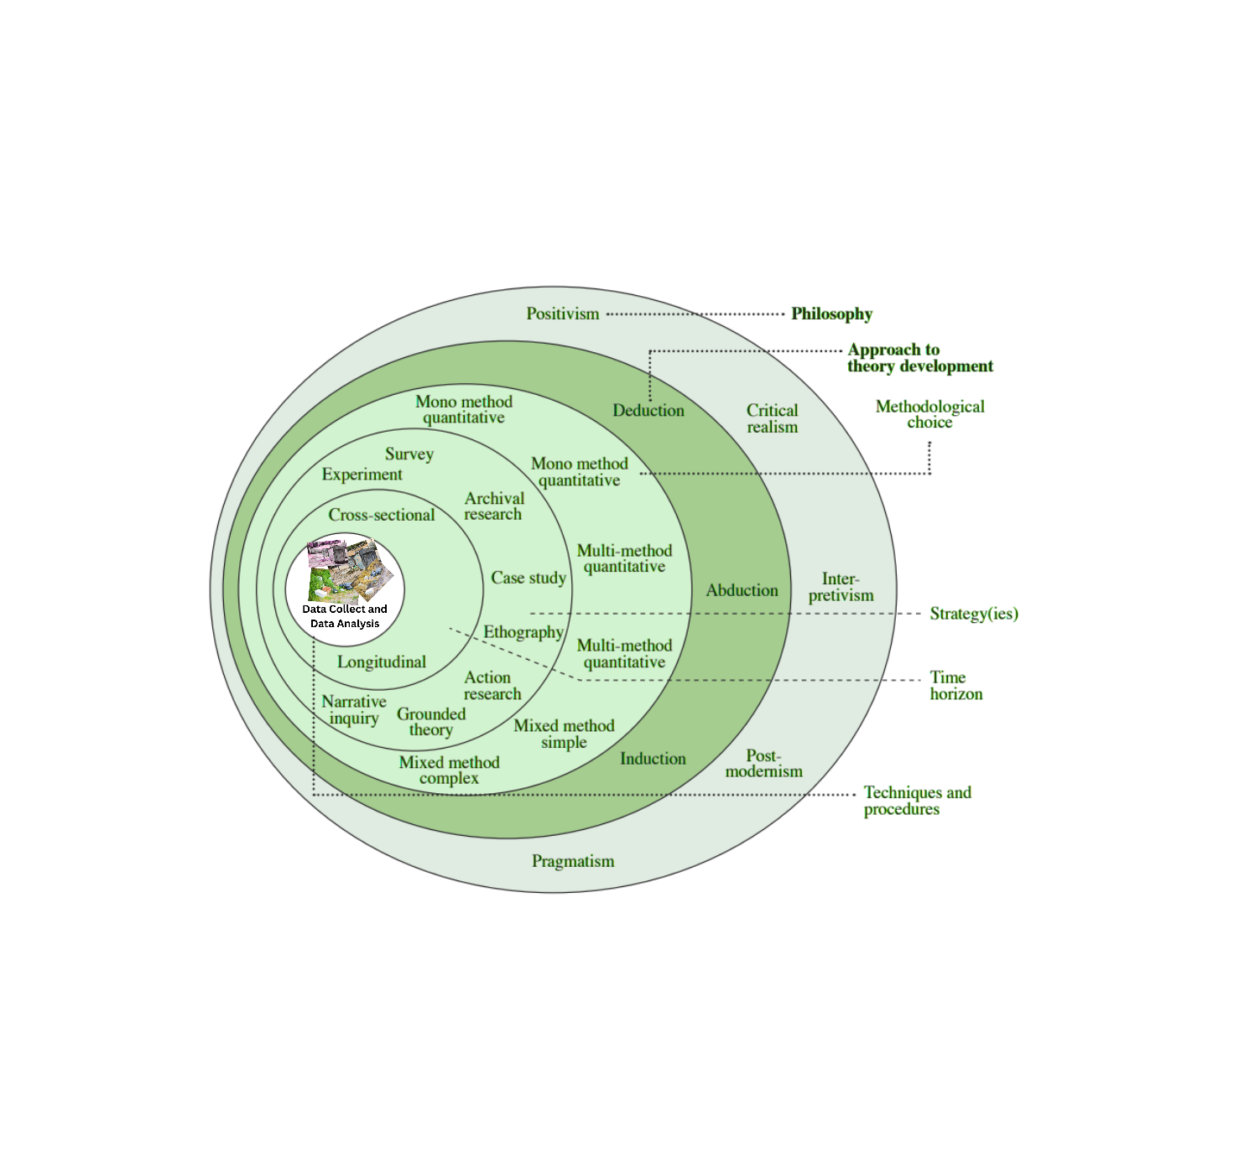

So, what’s the Onion Model? Imagine peeling an onion you can see that each layer is going to take you deeper into the core and that is exactly how this model works in research. It’s a step to step framework that helps structure your study, starting from big-picture philosophy down to the tiny details of how you actually collect data and each layer builds on the one before it making sure everything makes sense together.

### 3.1.1 Theory Development Approach

And this is as like how do you build your ideas? and we have three types or ways for it starting with the Deductive and this is going to start with a theory, then test it and this could be as like as a scientist and for the Inductive this is done by collecting data first and then figure out the theory and this could be as like as detective and for the Abductive this is like to keep adjusting your guesses based on clues.

For BiaEye inductive is the best fit cause nobodys done exactly this before like using YOLO models to track illegal dumping in Jordan. So, I explore first, see what the data tells us, and then build our approach from there.

### 3.1.2 Philosophy

And this is as like what do you believe? This is where I decide my basic beliefs about reality and knowledge so basically how do I see the world, and how can I learn about it? for positivism which means facts are facts we can measure them! meanwhile the Interpretivism means reality depends on peoples views and then we mix them to have the Pragmatism which is whatever works best, and because BiaEye isn’t just about cold, hard AI numbers it’s also about real people and how they interact with waste and so I have take the best of both worlds: quantitative which is for the model accuracy stats + qualitative which is about how people react to rewards, privacy concerns.

### 3.1.3 Time Horizons

And this is as like how long will it take? Starting with Cross Sectional which is one time snapshot as testing the model accuracy only and just only once, then we have the Longitudinal which is track over time monitoring illegal dumping trends for months so I have train the model once and this is cross-sectional and track waste patterns over weeks which is longitudinal to see if things are improve.

### 3.1.4 Methodological Choice

And this is such as like How Will You Study It? did it be Quantitative this is about numbers, stats, graphs like when I used YOLOv11 and see that the accuracy is 85% and also we have Qualitative and its about words, interviews, observations as seeing that people hated fines but loved rewards, then we have to use the best of both as I did in BiaEye I needed both to hard proof that the AI works and real feedback from users to make sure it’s actually helpful.

### 3.1.5 Techniques and Procedures

This is where you get super specific such as the tools that I did use RoboFlow for labeling images, Python for coding, GIS maps for tracking trash hotspots and the steps for this is first collect trash photos and then train YOLO models to est accuracy and finally set up reward systems for users those are really practical like RoboFlow makes labeling easy, YOLO is fast for real-time detection, and rewards keep people motivated.

### 3.1.6 Research Strategy

This is my game plan, like how will I actually do the research? Is it Experiments like to test YOLO models on trash images or its Case Study like try it in Amman and see what happens or is it Surveys like to ask the people what they think? For BiaEye first I test the AI in a controlled way and this is experiments and then I try it in the real world and this is case study to see if it holds up.

## 3.2 Data

First of all, I get the data from Kaggle and some were taken directly in Amman to the Trash bin that have garbage around it so by having these images from the targeted place its going to be more accurate to where this project is going to be used, and after collecting this data I’m going to label it with the classes I need, for this project I’m going to label them using only one class which is ‘Trash’ and for annotation and labeling I’m going to use RoboFlow where I’m going to put label (a unfill square with the label ‘Trash’) on each trash in the image. To to increase the number of images in the data, I’m going to use the augmentation such as the crop, and zoom in and zoom out and other augmentations.

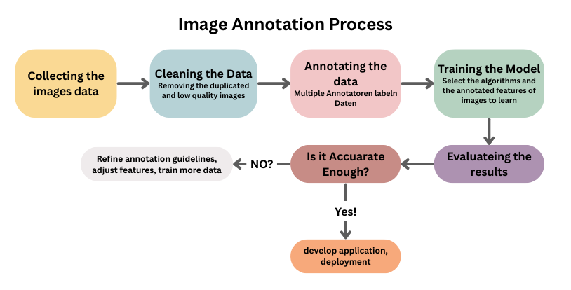

I made this diagram to make understanding the image annotation process for BiaEye easier, so first of all any CV system begins with collecting the data and it will be images for trash that are through illegally, then going to the cleaning, its really normal to face images that are duplicated to know that this image is duplicated you should compare pixel by pixel to see if the values are equal and those duplicated images are not useful and they will take only more space in the memory and might cause over fitting and its really not efficient to test a very large number of images for the model so easily we can delete them manually or using Python code even if the file name is not the same, so the code is going to compare the size of the images and the images if they are the same, here is the first part of the code:

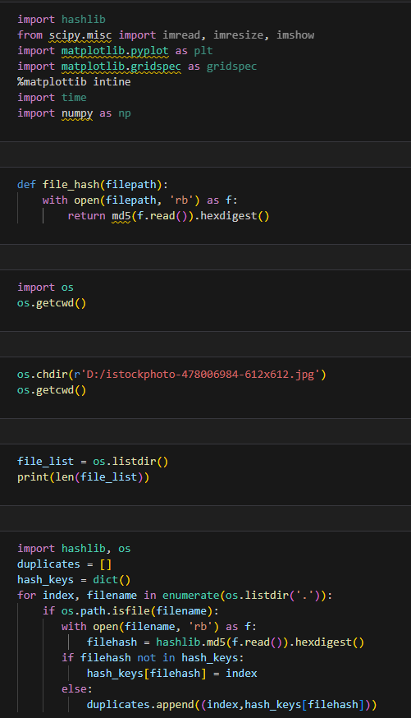

Here in the first part of the code to remove and delete the repeated or duplicated images so I’ve created a list to put the duplicates images in and initializing an empty ‘dic’ for the hash keys then reading every file and create for it an hash values to generate 32 of the hash values characters I’m going to use the ‘md5’ algorithm, the ‘hexdigest’ function is going to help in creating the hash values for every image, then entering the for loop to see if the file hash is not in the hash keys then give the file hash the index, else it is going to append those duplicates to the list of the duplicated images.

Then when I run the ‘duplicates’ I’m going to see the output as the list of the images that are duplicated, and then to remove them I’m going to use the following code, and then recheck if there still any repeated images.

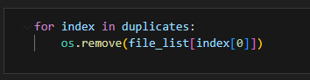

And also for the data cleaning, there might be images with a very bad quality so I’m supposed to remove them because they are going to make the performance of the model very bad.

Here is the diagram that will make understanding the data collecting and cleaning easier:

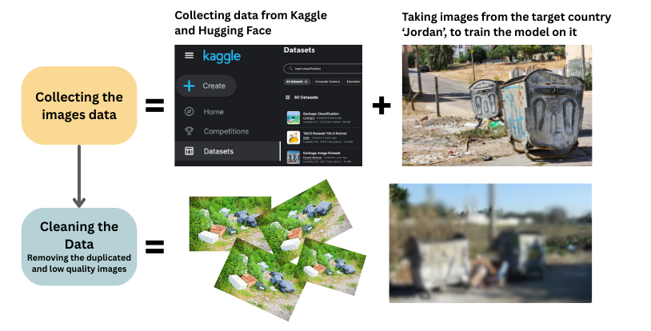

**Secondary Data:**I have collected the secondary data from Kaggle from different publishers, the data is for trash, different types of trash in various environments, and different lighting, the final number of images that I have collected was around 1000 – 3000 after augmentation.

**Primary Data:**

And also for the primary data from my country, I have taken photos from Amman because the project is going to start first in Amman so to have a better results I have to have a real data from the environment I target, and also you can see the low quality image and those repeated images.

Going to the third step which is Annotation, where its about labeling the data with the class that I want the model to predict, here is the diagram that I have create that shows the steps to annotate the data:



As shown I have used ‘RoboFlow’ a website that provides the tools that help in annotation, first I’m going to create a workspace and create and project in it this work place helps in inviting people to help in annotation because it does really takes a lot of time, then I did upload the images that shows trash in different environments and backgrounds, then I’m going to start annotation for every image by drawing a rectangular boxes around the trash and one image might have more than one trash so it will have more than one bounding box and this box must cover the whole trash object and be in the edges of this object, in some cases its better to use the AI annotation but in my case it was more accurate to annotate the images by myself because this was the result when I used AI:

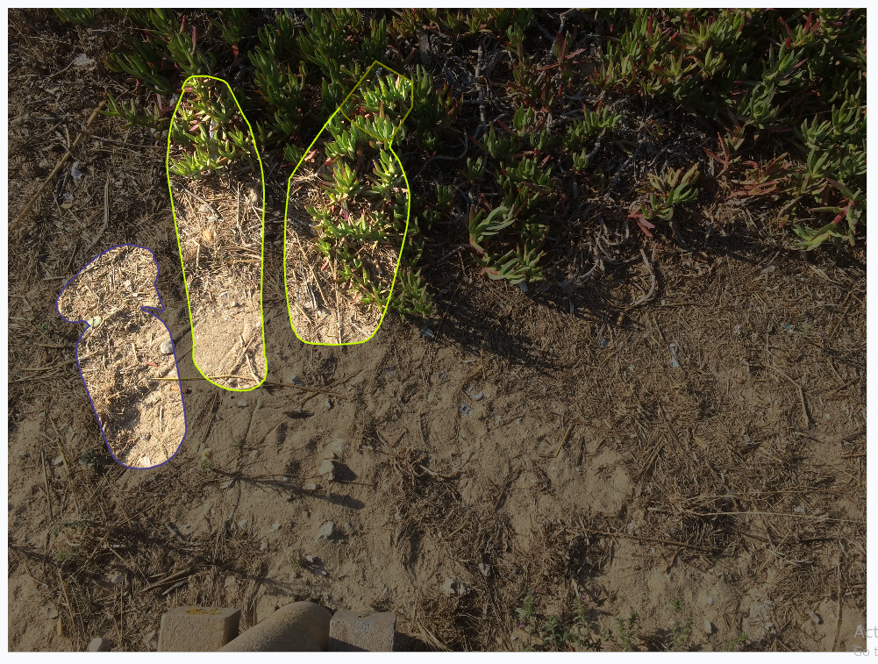

Its labeling objects that does not even exist.

After finishing all the image annotations, I’m going to split the images to training, testing, and validation to use the models in Roboflow to check whether my annotations was good or not, and the results as in the diagram down shows that its accurate and the model could detect the trash in the image that I have upload and also it did gave me the analysis for the model.

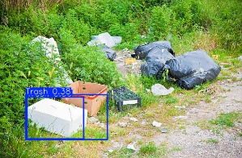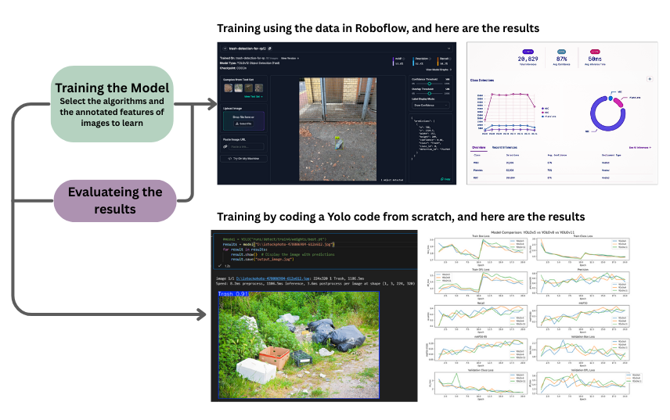

Then after checking how much the annotation is accurate I’m going to start coding and setting and tunning the parameters for the model.

## 3.2 Real-Time Detection System

And now I will explain how does YOLO for object detection works,

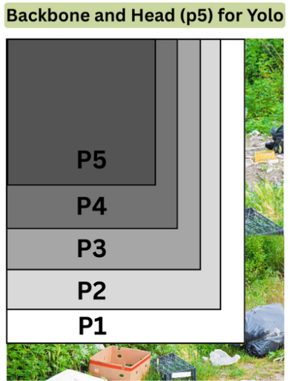

Each layer in the backbone is going to transform the image into a increasingly abstract and an semantic feature representations where every early layer is going to capture the basic visual elements, meanwhile the later layer is going to encode complex patterns that are really crucial for accurate object detection.

|  |  |
| --- | --- |
|  | - In first layer which is the convolution layer in P1 is going to capture the basic visual features such as the edges and textures, by putting the parameters where the filter size or the kernel will equal to 3*3 and the stride size will be 2 that’s means that the dimension will be downsampled into the half, meanwhile the padding will be only one pixel on all sides, so by this the row RGB image will be transform from 640*640*3 to the feature map 64 so the dimension will be reduced into 320*320, and this layer is really the most importance because it does creates the initial represent of all the next layers that are going to be build.  - In next layer which is the convolution layer in P2 is going to capture the increase the features depth, by putting the parameters where the filter size or the kernel will equal to 3*3 and the stride size will be 2 that’s means that the dimension will be downsampled into the half, meanwhile the padding will be only one pixel on all sides, so by this the row RGB image will be transform from 320*320*64 to the feature map 128 where these channels have been doubled now so the dimension will be reduced into 160*160*128, and this layer is really the most importance because it start captures more and more complex patterns because of the number of channels that have been increased.  - Now going to the cross stage partial network where it does enhance the gradient flow and reduces the computational complexities, and the parametyers that I put are the shortcut that is going to help with the gradient flow during training by using the residual connections and the internal block that equal 3+d where d is depending on the model size.  - and now we have another convolution layer for P3 which going to have a further downsampling that helps in capturing the mid-level features, by putting the parameters where the filter size or the kernel will equal to 3*3 and the stride size will be 2 that’s means that the dimension will be downsampled into the half, meanwhile the padding will be only one pixel on all sides and its going to transfer the dimensions from 160*160*128 to 80*80*256 and as well doubling the channels, so this layer is important because it is going to create a mid - scale features those who are realy important for detecting mid - size objects.  - and now to enhance the features that have been extract in the p3 level we are going to have the C2F Block, with the shortcut that is going to help with the gradient flow during training by using the residual connections and moore internals blocks that is going to enable deeper feature processing n=6+d, and it does process 80*80*256 features and it is without changing the dimensions and as well those are deeper features that are going to enriches mid-level context information.  - for the fifth convolution layer for P4 which going to have a further downsampling that helps in capturing the higher-level features, by putting the parameters where the filter size or the kernel will equal to 3*3 and the stride size will be 2 that’s means that the dimension will be downsampled into the half, meanwhile the padding will be only one pixel on all sides and its going to transfer the dimensions from 80*80*256 to 40*40*512 and as well doubling the channels, so this layer is important because it is going to create a smaller scale to detect a large objects and more patterns.  - again with the C2F Block in P4 level, cross stage partial network where it does enhance the gradient flow and reduces the computational complexities, and the parameters that I put are the shortcut that is going to help with the gradient flow during training by using the residual connections and the internal block that equal 3+d where d is depending on the model size, and it does process 40*40*512 features and it is without changing the dimensions and as well those are deeper features that are going to enriches high-level semantic information.  - and now getting to the last conv layer by putting the parameters where the filter size or the kernel will equal to 3*3 and the stride size will be 2 that’s means that the dimension will be downsampled into the half, meanwhile the padding will be only one pixel on all sides and its going to transfer the dimensions from 40*40*512 to 20*20*512 and as well doubling the channels and this is going to help in creating the smallest scale features that will help in detecting the largest objects and most abstract patterns.  - then we are going to have the final C2F layer as the same as the above with different dimensions and at the last layer we will have the SPPf which is the Spatial Pyramid Pooling Fast variant enhances the receptive field without adding as much computational cost, with a stride equals to 32 which is the total downsampling factor from the original image, this layer is going to apply the pooling operations using differ scales which captures multiscale context info. |

|  |
| --- |
|  |
| As shown from the backbone output we have the p’s features map from the largest p1 to the small resolution which is p5 where when the color is darker the layer is deeper, so we have the three main paths from p3, 4, and 5 and then the Concatenation operation is shown from every line which merges the features and after it we have the C2F which is the Cross Stage Partial Fusion modules that going to process the features efficiently, and then we have the U which means the upsampling op that is going to increase the features map resolution, and then we have the convolution layer the three lines end in P3, P4, P5 different scales then each is connected to the detect which going to produce the actual object detection so first the top one P3 will detect the small obj and the second one P4 will detect the mid obj an d the bottom path will detect the large objects. |

And here is the whole layers and process of how Yolo v8 does work in a very amazing way to have the best predictions.

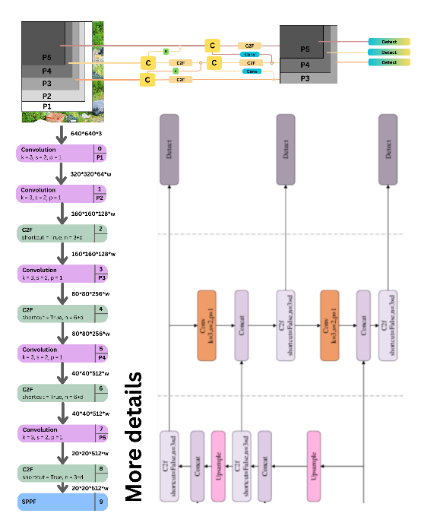

# 4. Computer Vision Models: Techniques and Comparisons

## 4.1 Models Used in BiaEye

I have used three models from Ultralytics which are the Yolov5 and version 8 and 11

Here is the explanation of YOLO model code, where I have used Ultralytics which is the last advancement in Yolo for object detection and segmentation, and to use it we can import Yolo from Ultralytics after installing it,

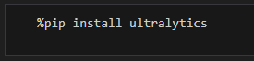



After this I’m going to load the yolo version pre trained model which is the nano version because its small and really fast,



Then I am going to start tuning the parameters and train the model in the GPU of my laptop because it does takes a ling time training in the CPU, and first we are going to get the dataset YAML file that have the trained, test, and validation data that I have just download it from Roboflow as a Yolo type,



Then using the epochs I’m going to train the model 100 times or less if you want to have the results faster, and I will resize all the image to have the same size which is 320*320 but you can make it 640*640 because already Yolo version 11 support this size, then device = 0 as I say because I want to use the GPU of the laptop and to reduce the memory use I’m going to use the half precision and also an importing thing is to use the learning rate to minimize the size of the steps to find the best gradient so I will give it the value 0.001 and I will use the learning rate scheduler also and also an important thing is to reduce the overfitting and this happens by applying the dropout regularization and in every batch I am going to process 8 images and at the end to also make the train faster I am going to preload the data in the RAM.

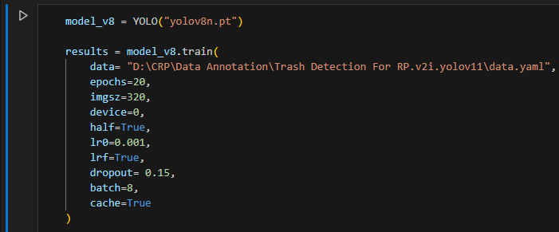

And at the end to check the results I’m going to use this model that I gave these parameters and upload an image from my laptop that the model have never seen to see its predictions if its accurate or not,

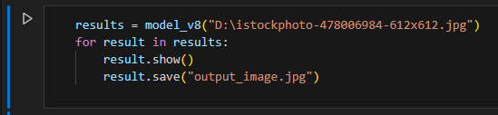

And here is the output labeled image that shows that the model is accurate and it did detect the trash very well,

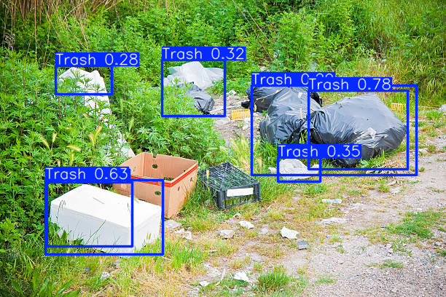  
the output shows,

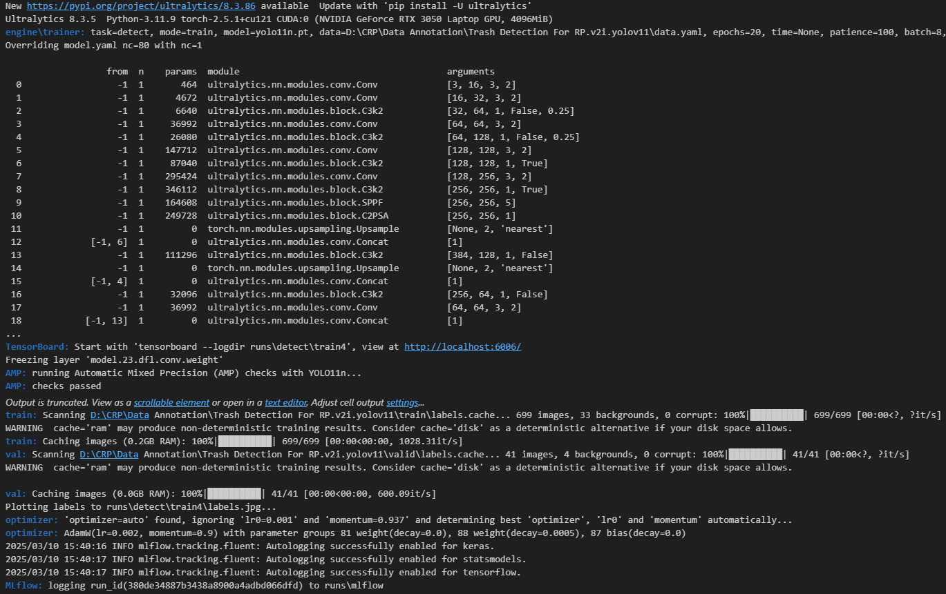

The training config where its task is object detection and the model used in this code is Yolo v11 the nano version nd the rest as I mention above, while the model config shows that the model contains convolution layer and a bottleneck block and the SPPF which is the pooling as I mention in the structure of YOLO and also it contains the feature pyramid network components where they are the concat and the upsample the total number or parameters are lets say around 2.5 million parameter, and for the key metrics in the training we have the bounding box regression loss and the classification loss, the distribution focal loss the MAE and the mAP across the IoU thresholds.

And after the final epoch the validation metrics was:

|  |  |  |  |  |
| --- | --- | --- | --- | --- |
| Precision | Recall | mAP50 | mAP50-95 | Inference speed |
| 0.67 | 0.366 | 0.427 | 0.225 | 5.8ms per image |

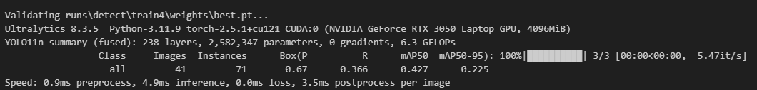

## 4.2 Model Comparison

Use a table to compare key metrics for each model:

|  |  |  |  |  |  |
| --- | --- | --- | --- | --- | --- |
| **Model** | **Speed (FPS)** | **Accuracy (mAP)** | **Model Size** | **Strengths** | **Weaknesses** |
| YOLO v8 | 4.91 | 0.479 | 2.7M param | High accuracy and as well a modern architecture and a realy good balance of speed & size. | It is slower than yolov5 and slightly more large than the yolov11. |
| YOLO v5 | 7.38 | 0.128 | - | The fastest inference speed and as well a stable performance. | It does have a very low accuracy and outdated. |
| YOLO v11 | 5.47 | 0.427 | 2.5M param | It does have the best speed accuracy tradeoff and its as well smaller than YOLOv8 and does have a good precision. | Its mAP is lower than the mAP for yolov8. They can make it by experimenting it. |

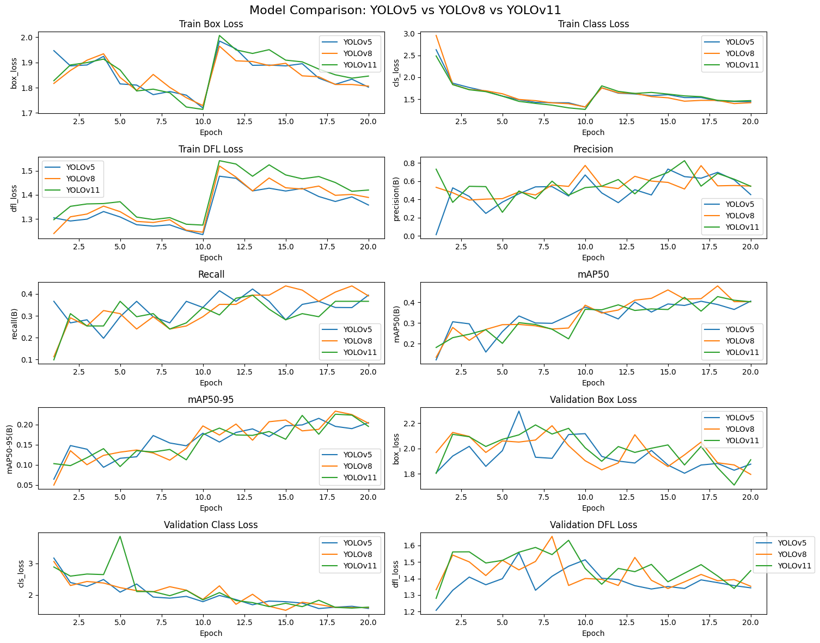

This plot is for comparing the three models that I have used in this project, YOLOv5 ,YOLOv8 , and YOLOv11, and now explaining every plot what does it means, the train box loss that does measures how well does predicted bounding box is fit with the truth where we can see that yolov8 has win because it shows lower box loss, and for the train class loss that’s going to measure the classification error during the training and as we see all the models start with a low loss and as we can see v8 and v11 are the best in classification the trash, then we have the train distribution focal loss where its used in detect trash to improve box regression, then we have the precision = TPTP+FP×100 showing the actual trash that have been detect by the model where we can see that v11 did captures more true trash, while the recall =TPTP+FN×100 where the v8 had win, and the mAP5.0 = mAP=1| 𝑄𝑅| ∑𝑞 ∈ 𝑄𝑅AP (𝑞) which is the mean average precision at the IoU threshold 5.0 in here the v8 is the best and as well in the 5.0-0.95 ,for the validation box loss which does assesses localization accuracy on the not seen data where we can see that v8 and v11 were the best, but for the validation class loss the v8 was the best where this does measures the classification loss on the valid data and at the end we have the validation distribution focal loss that is going to track the quality of prediction for the bounding box on the not seen data where also the yolo v8 is the best, and I made this table to see the best model in every plot clearly,

|  |  |  |  |  |  |  |  |  |  |  |
| --- | --- | --- | --- | --- | --- | --- | --- | --- | --- | --- |
| **Plot** | Train Box Loss | Train Class Loss | Train DFL | Precision | Recall | mAP5.0 | mAP5.0-0.95 | Val Box Loss | Val Class Loss | Val DFL |
| **Best Model** | YOLOv8 | YOLOv11 / v8 | YOLOv8 | YOLOv11 | YOLOv8 | YOLOv8 | YOLOv8 | YOLOv8 | YOLOv8 | YOLOv8 |

## 4.3 Analysis of Model Performance

**Evaluating the measures curves**:

|  |  |  |  |
| --- | --- | --- | --- |
| This is the recall confidence curve, where the x axis shows the confident threshold from 0 to 1 and the y axis shows how many true positive were detected from the positive actual images. First when the confident was low the recall was high and as the conf is increasing the recall is decreasing so this means that the model is really sensitive to conf. | This is the f1 score confident curve where the x axis shows the confident and the y axis shows the mean of the precision and recall the first jump is show that it’s the best confident for f1 score so in the left side we can see that the recall is high and the precision is low that’s means that we have many false positive and shows a low confident and in the right side we can see that we have high precision and low recall which means that we have many false negative and shows a high confident, so looking in this plot we can see that the best practice was when it was 0.259. | This curve is for the precision recall, where the x axis shows the recall and the y axis shows the precision and as we see when the recall increase the precision drop and this means that the model did find a lot of objects but it also makes a lot of mistakes and going to when the line is looking horizontal that does means that the model is better with a high recall and a good precision. | This is the precision confident curve where the x axis shows the confident and the y axis shows the precision and as we see as the confident increase we are getting less false positives because the precision improves and when the confident is near 0.639 that means the model get a perfect precision, then at low confident it rize up to show a less confident and reduces the precision. |

* **Dataset Performance**:

Models performed really well on the dataset, as shown in the image where I did fit the model to test it in the following image where the model have never been trained on it. And the number above the boxes show how much the model is confident that this object is a trash.

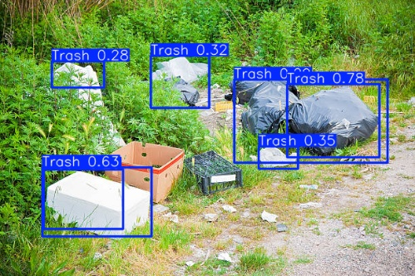

And this analysis is from Roboflow where I have finished training the model in the images that I have annotated so it shows that the model is 0.87 confident which is really good and it did take 50ms time to finish which is a fast model.

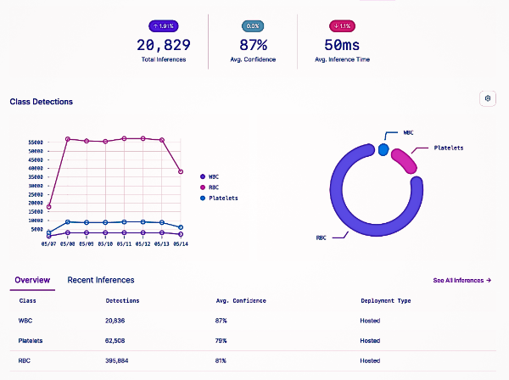

* **Trade-Offs**:

Highlighting the speed vs. accuracy for the three models,

|  |  |  |
| --- | --- | --- |
| **Model** | **Speed (FPS)** | **Accuracy (mAP)** |
| YOLO v8 | 4.91 | 0.479 |
| YOLO v5 | 7.38 | 0.128 |
| YOLO v11 | 5.47 | 0.427 |

## 4.4 Model Selection for BiaEye

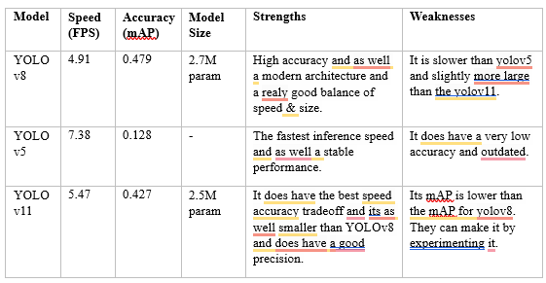

This table shows that the Yolo v8 is the best to use, but when I fit the model and test it in that image,

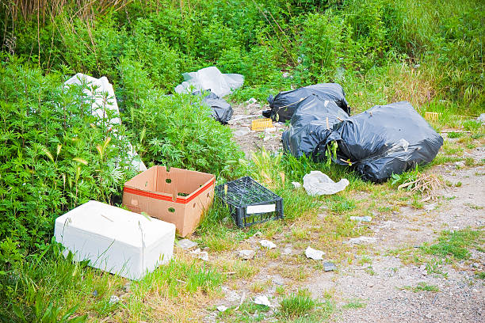

And the best output was from the Yolo v11 model cause it could detect the most trash in the image

|  |  |  |
| --- | --- | --- |
| YOLO v5 | YOLO v8 | YOLO v11 |
|  |  |  |

## 4.5 Geospatial Analytics

First the data will be collected using the AI powered camera that in install in the garbage truck it will take a real-time, high-resolution image along the way, and when it approaches a waste bin, if there is garbage thrown around the bin and not inside it, it will put points on this area, and at the end of each round, data will be saved with the amount of garbage found thrown and where it was found, and there will be a weekly report for each area that will be sent to the responsible authority, whether it is the Greater Amman Municipality or the Ministry of Environment, so that this report will help the responsible authority in making a decision. For example, if the report shows that area (A) during the past two weeks did not reduce the garbage thrown on the road, the matter will be studied. It is possible that the area has a large population, such that they need more waste bins where this is using the location-allocation modeling, and it is possible that because the soil around the bin has become bad, a decision will be made to plant plants around the bin to beautify the area. There are other reasons, for example, that the waste bin is located in an area far from the residents, so it is difficult to reach it, so they throw garbage in other places not designated for throwing, so these areas turn into an illegal waste dump and as its call Dead zones. And also we can use the route optimizer that will help in reducing fuel cost by optimizing the garbage truck routes where I did a simulation that have showed that this is going to help in reducing by 15% and this is called data driven waste management.

________________________________________________________________________________________________



________________________________________________________________________________________________

Also I have created a website for the users where they can check the impact of our project BiaEye and also to engage them I have made a reward system where the users enter their location and it will be saved in the system so when the AI powered cameras detect that in this location there was illegal trash it will be send as a report to the admin and during the week if the users who live in this location did join hands and help remove and clean this garbage thrown on the way so when the garbage truck comes again and does not see any garbage, through data analysis, a weekly report will be sent. If this garbage is removed, all residents of the area will receive a reward (it may be a discount on the electricity and water bill). However, if the report shows that garbage is still thrown on the road, residents will be fined.

# 5. Achievements

BiaEye has been a finalist at GJU's "Creative Solutions" competition also it was chosen for incubation in StartUps at the Ministry of Digital Economy and Entrepreneurship and has been showcased at COP29 in Azerbaijan and during World Youth Day 2024.

# 6. Ethical and Privacy Considerations

One of the most important things that the camera mounted on the garbage truck must avoid is photographing people's faces. If this happens, the system will follow the rights protection law, and people's faces will be blurred and misled, not just faces, but even car and house numbers. If any number or private data appears, it will be completely blurred and misled. Any data that is photographed or recorded will not be shared with anyone or even sold, as it is saved data that is used only for the purposes for which it was published, such as benefiting from it for analysis or decision-making. Therefore, before the user enters any of his data on the site, he will be shown the methods for using his data and whether he agrees to it or not, as well as what will be photographed, how long the data will be kept, and what data we will use. In private places such as army, police, and ministries, the images will be completely erased and reports will be sent only to waste. To ensure complete data protection, we will use data encryption techniques and anti-hacking programs, also BiaEye can publish public dashboards showing detected waste trends without personal data.

# 7. Challenges and Future Work

While BiaEye offers a transformation in waste management and treatment, it may face technical, financial, and even social challenges. For example, there may be a lack of image data from Jordan for the AI ​​model to be trained properly and produce satisfactory and effective results. There may even be some problems in connecting cameras to the AI ​​waste detection system. It is also possible that the weather conditions themselves are the problem, blurring the camera's view, or even lighting may also be disrupting the camera.

In the future, it is possible to use a better artificial intelligence model that is capable of detecting waste faster and more accurately. This also depends on the availability of data. It is possible to use better, faster algorithms that require less volume and energy consumption when uploading them to garbage trucks. It is also possible in the future to expand the field of waste management for users, as they can photograph the waste with their devices through applications. The best thing that can be done is to involve effective government agencies and also involve private entities in this project to support and assist us and to do a great promotion for the project to reach the largest number of people in Amman and expand in the future to include most of the governorates of Jordan and the Arab world.

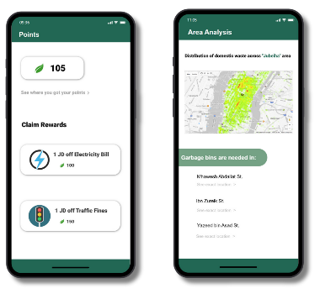

# 8. Conclusion

BiaEye truly represents a paradigm shift in waste management leveraging AI-powered computer vision and geospatial analytics to address Jordan's and even the global escalating urban waste crisis and illegal dumping. By detecting waste, optimizing bin locations and enabling data-driven policy decisions the system addresses critical shortcomings in traditional waste management reducing environmental pollution lowering municipal costs and improving public health. The integration of real-time monitoring adaptive AI models and community engagement ensures it is scalable across diverse urban environments from densely populated cities to underserved areas and while challenges such as computational requirements dataset biases and funding barriers remain future developments in edge AI crowdsourced data collection and public-private partnerships promise to further enhance BiaEyes impact transforming it from a pilot solution to a global standard for smart cities. Beyond waste management the BiaEye framework sets a precedent for the ethical use of AI in environmental conservation demonstrating how technology can align environmental sustainability with urban growth. As cities around the world struggle with a waste epidemic BiaEye offers not only a cleaning tool but also a proactive and scalable blueprint for a cleaner healthier future where AI and human collaboration transform pollution.

# 9. Reflections

## 9.1 Selected Research Methodology

When I first started BiaEye I knew I needed a structured approach that could handle both the technical side training AI models and the human side community engagement. The Onion Model gave me exactly what I needed which is a clear framework that took me step to step from big picture philosophy all the way down to the nitty-gritty practical details. It help me organize everything from my core beliefs about research to the specific tools I had use for data collection.

Several things worked really well with this approach and the pragmatic philosophy was perfect because it let me combine hard numbers like model accuracy scores with real human feedback about the system. Since there was not much existing research about using AI for illegal dumping in Jordan, the inductive approach worked great I could let the actual data guide my conclusions rather than being locked into pre-existing theories. The mixed methods were especially valuable because while the quantitative data showed the technical performance, the qualitative research uncovered important practical issues I never would have considered, like people's privacy concerns about the cameras.

Of course, there were some limitations and pitfalls too and as well my dataset had bias issues since most training images came from Kaggle rather than Amman adding local photos helped, but I needed more. The YOLOv11 model was fast but sometimes missed smaller trash piles, suggesting a larger dataset could improve results. And while the reward system motivated users, the fines created backlash - in hindsight, sticking to positive reinforcement might have worked better.

## 9.2 Alternative Research Methodologies

Looking back, I often wonder if different research approaches might have worked better. A deductive, theory first method would have given me more structure and made comparisons with past studies easier, but it might have missed Jordans unique waste management challenges that only emerged through direct observation and going purely quantitative could have strengthened my models statistical validity, but at the cost of ignoring crucial human factors like understanding why people dump trash illegally in the first place. An ethnographic deep dive might have revealed richer cultural insights about waste attitudes, but the time investment would have been impractical for scaling an AI solution. These alternatives taught me two valuable lessons: first, that balance is everything focusing solely on technical metrics would have created an impressive system on paper that failed in reality. Second, local context is invaluable even just a handful of Amman-specific training images made a noticeable difference in my model's accuracy, proving that small, targeted data can be more valuable than large generic datasets. Ultimately, while other methods had their merits, the blended approach I chose gave me both the hard numbers I needed and the human understanding required for real-world implementation.

## 9.3 Recommended Actions and Future Considerations

Several key improvements could significantly enhance the project's impact. First and foremost, we need to improve data diversity by partnering with local municipalities to collect more real-time, location specific trash images this would reduce algorithmic bias and improve detection across different environments, from crowded urban streets to rural areas. The reward system also needs refinement; testing nonmonetary incentives like community leaderboards or public recognition could maintain high engagement without the negative backlash we saw with fines. On the technical side, implementing a hybrid model approach that combines YOLOs speed with a segmentation model like Mask RCNN would help catch smaller or scattered trash items that currently get missed. Perhaps most importantly, we must commit to longitudinal impact tracking over 6 ~ 12 months rather than just weeks, as this extended monitoring period will reveal whether the system creates lasting behavioral change or merely temporary improvements. Together, these enhancements would address both the technical limitations and human factors we encountered, creating a more robust and sustainable solution.

## 9.4 Recommended Methodology

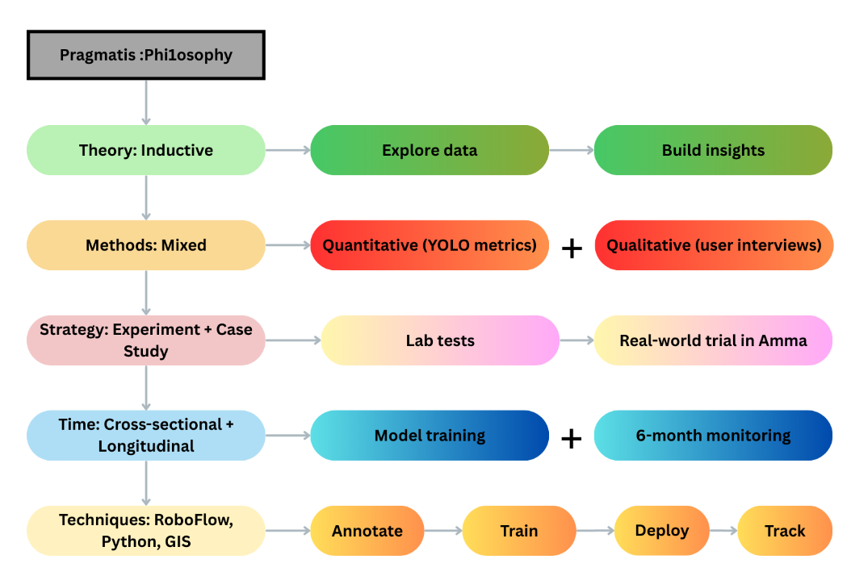

This project takes a pragmatic philosophy approach mixing realworld testing with hard data. Instead of starting with theories, I let the trash data itself show me patterns. I used both numbers like YOLO model scores and peoples opinions to make sure the tech actually helps in reality. First tested in lab conditions, then tried in actual Amman neighborhoods. Tracked results both short-term initial tests and long-term 6 months monitoring. For the dirty work, used RoboFlow to label images, Python to build the AI, and mapping tools to track trash hotspots - following steps from labeling to training to real-world use. This whole messy-but-organized process kept things practical while still being properly scientific.

References

Al-Tahmeed, A. 'YOLOv8 Train and Predict', *Kaggle*. Available at: <https://www.kaggle.com/code/ahnaftahmeed/yolov8-train-and-predict>

Cube AI 'Trash Detection for YOLOv8', *Kaggle*. Available at: <https://www.kaggle.com/datasets/cubeai/trash-detection-for-yolov8>

Cube AI 'Trash Detection with YOLOv8', *Kaggle*. Available at: <https://www.kaggle.com/code/cubeai/trash-detection-with-yolov8/notebook>

DataCamp 'YOLO Object Detection Explained', *DataCamp*. Available at: <https://www.datacamp.com/blog/yolo-object-detection-explained>

Digital Ocean 'Filters in Convolutional Neural Networks', *Digital Ocean*. Available at: <https://www.digitalocean.com/community/tutorials/filters-in-convolutional-neural-networks>

EZGif 'Video to GIF Converter', *EZGif*. Available at: <https://ezgif.com/video-to-gif?err=expired>

Google 'Google Colaboratory', *Google*. Available at: <https://colab.research.google.com/>

Hadi, D. and Jaber, M. (2023) 'Waste Classification Using Artificial Intelligence Techniques—Literature Review', *ResearchGate*. Available at: <https://www.researchgate.net/publication/368500374_Waste_Classification_Using_Artificial_Intelligence_TechniquesLiterature_Review>

Kalemi, E., Papageorgiou, A. and Stylianou, E. (2023) 'Smart Cities and the Role of Artificial Intelligence for Sustainable Waste Management', *MDPI*, 7(4), p. 88. Available at: <https://www.mdpi.com/2624-6511/7/4/88>

Khedairia, I. et al. (2024) 'AI Powered Waste Classification: A Comprehensive Review of Methods, Applications, and Challenges', *International Journal of Advanced Computer Science and Applications*, 15(10). Available at: <https://thesai.org/Downloads/Volume15No10/Paper_9-AI_Powered_Waste_Classification.pdf>

Ministry of Environment Jordan 'Jordan Waste Sector', *Ministry of Environment*. Available at: <https://www.moenv.gov.jo/ebv4.0/root_storage/ar/eb_list_page/20022_jordan_waste_v02_rc_web.pdf>

Rana, M.T., Sarkar, S. and Chua, C.P. (2024) 'A novel solid waste instance creation for an optimized capacitated vehicle routing model using discrete smell agent optimization algorithm', *Waste Management*, 175, pp. 228-242. Available at: <https://www.sciencedirect.com/science/article/abs/pii/S0956053X24006469>

Roboflow 'Annotate', *Roboflow*. Available at: <https://roboflow.com/annotate>

Roboflow 'Create a Project', *Roboflow Docs*. Available at: <https://docs.roboflow.com/datasets/create-a-project>

Roboflow 'GitHub Repository', *GitHub*. Available at: <https://github.com/roboflow>

Sadeh, R. 'Robotic Arm Balancing DQN', *GitHub*. Available at: <https://github.com/RaneemSadeh/Robotic-Arm-Balancing-DQN>

Sidhar, K. (2023) 'Image Classification with YOLOv8', *Medium*. Available at: <https://sidharkal.medium.com/image-classification-with-yolov8-40a14fe8e4bc>

Song, S., Chen, J. and Shi, W. (2024) 'Network structure of YOLOv8', *ResearchGate*. Available at: <https://www.researchgate.net/publication/381457689/figure/fig1/AS:11431281252009889@1718495216183/Network-structure-of-YOLOv8.png>

Song, S., Chen, J. and Shi, W. (2024) 'Network structure of YOLOv8', *ResearchGate*. Available at: <https://www.researchgate.net/figure/Network-structure-of-YOLOv8_fig1_381457689>

Soni, U. (2021) 'Removing Duplicate Images Through Python', *Medium*. Available at: <https://medium.com/@urvisoni/removing-duplicate-images-through-python-23c5fdc7479e>

Ultralytics 'Documentation', *Ultralytics Docs*. Available at: <https://docs.ultralytics.com/>

Ultralytics 'Official Website', *Ultralytics*. Available at: <https://www.ultralytics.com/>

Ultralytics 'YOLOv5 Usage Examples', *Ultralytics Docs*. Available at: <https://docs.ultralytics.com/models/yolov5/#usage-examples>

Ultralytics 'YOLOv8 Documentation', *Ultralytics Docs*. Available at: <https://docs.ultralytics.com/models/yolov8/>

Ultralytics 'YOLOv11 Documentation', *Ultralytics Docs*. Available at: <https://docs.ultralytics.com/models/yolo11/>

Valero, P. et al. (2023) 'Artificial intelligence for waste management in smart cities: a review', *ResearchGate*. Available at: <https://www.researchgate.net/publication/370680681_Artificial_intelligence_for_waste_management_in_smart_cities_a_review>

Wang, H. et al. (2024) 'A comprehensive survey on YOLO, deep learning, vision models, and toolkits', *IEEE Xplore*. Available at: <https://ieeexplore.ieee.org/document/10676971>

YOLOv8 'Official Website', *YOLOv8*. Available at: <https://yolov8.com/>

10web 'Single Page Demo', *10web*. Available at: <https://my.10web.io/single-page-demo>

Canva 'Design Platform', *Canva*. Available at: <https://www.canva.com/>

https://www.google.com/url?sa=i&url=https%3A%2F%2Fwww.linkedin.com%2Fpulse%2Fhow-you-can-help-tackle-climate-change-studying-environmental&psig=AOvVaw15u3S_fzXhsLA3VYpKBkJP&ust=1744127285918000&source=images&cd=vfe&opi=89978449&ved=0CBQQjRxqFwoTCNjckdCixowDFQAAAAAdAAAAABAP